Timothy Leishman Word Count: 00,000

Pocatello, Idaho, 83202

[leistimo@isu.edu](mailto:leistimo@isu.edu)

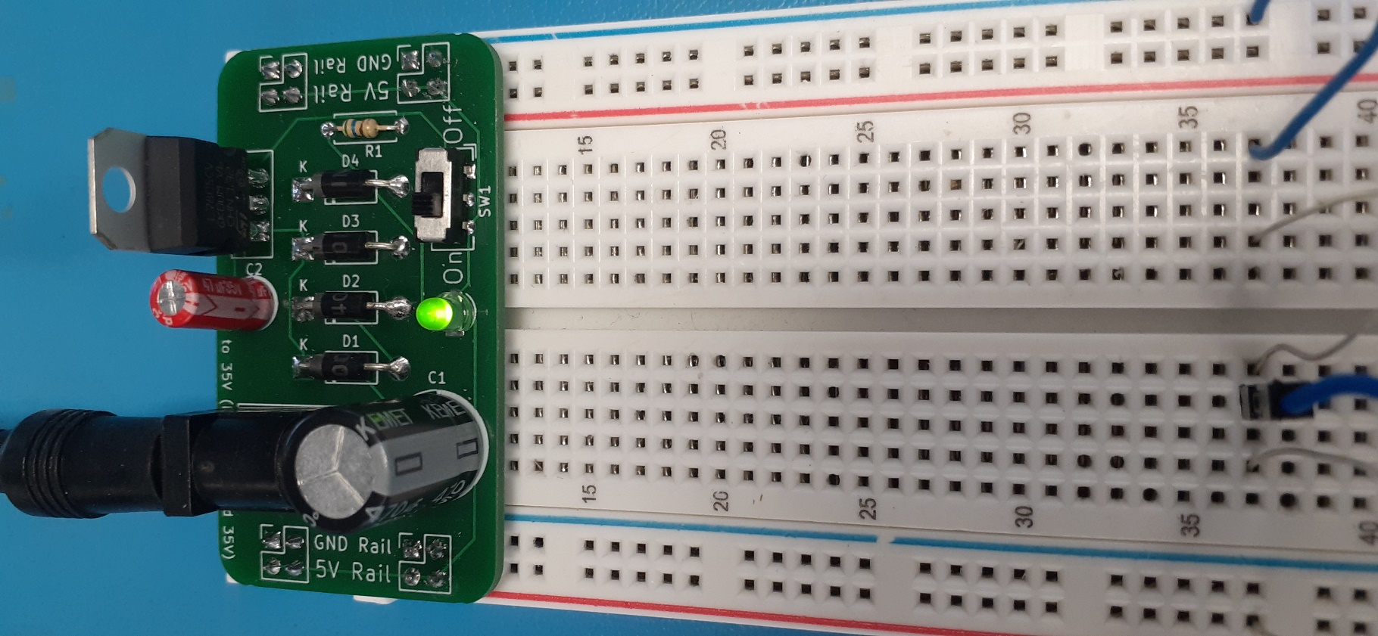

**Breadboard Power Supply**

**Timothy Leishman**

*Senior Instructor, Robotics Engineering Technology*

*Idaho State University*

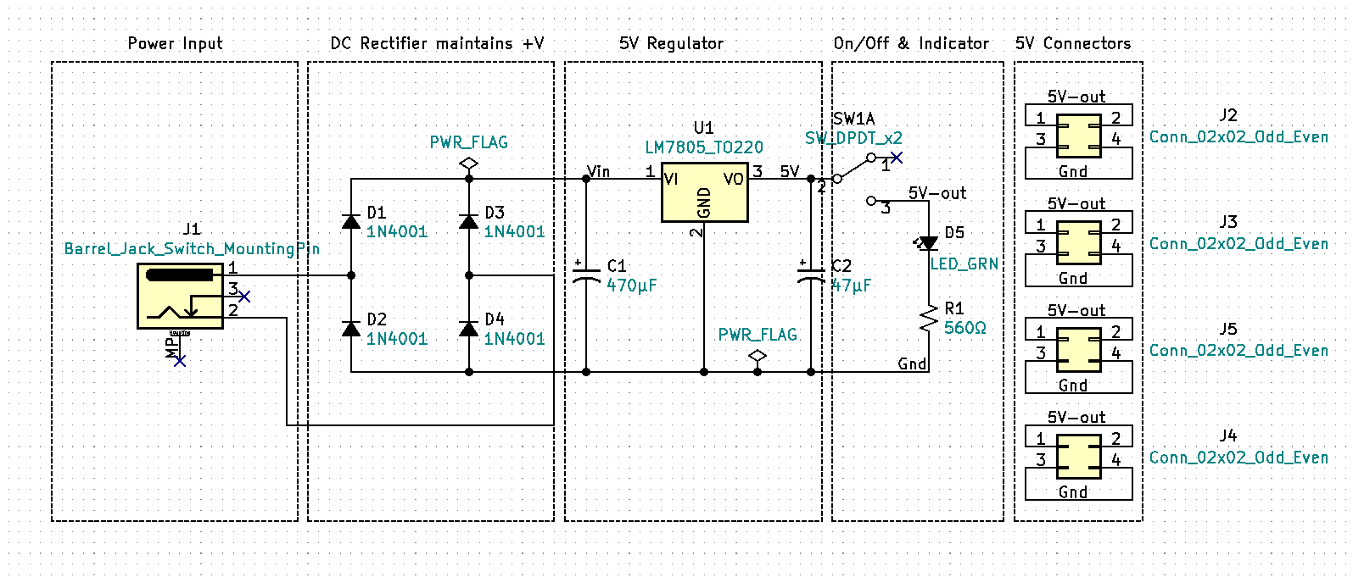**Introduction**

Figure 1. Breadboard Power Supply Schematic

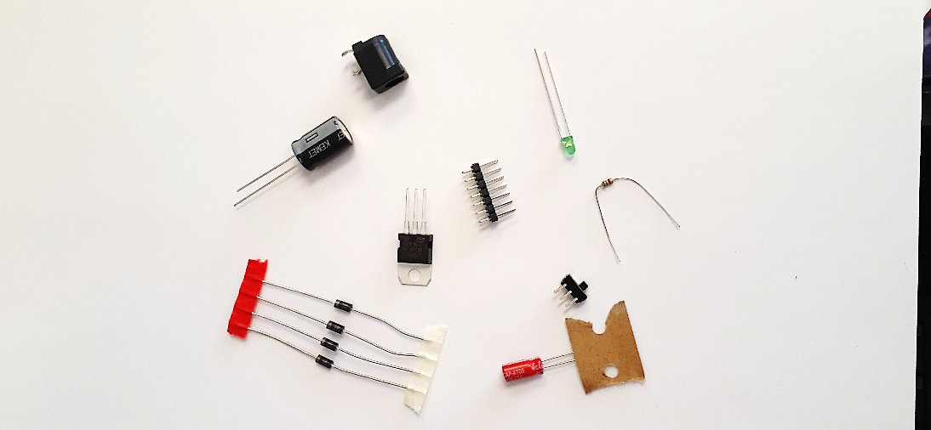The electronic circuit design process involves defining the problem, determining a solution, circuit calculations & schematic development, acquiring the needed components, circuit testing (often referred to as breadboarding), PCB or printed circuit board development, PCB assembly, and final testing. Typically, the breadboarding stage is done using a bench top or Laboratory DC Power Supply. Once the breadboarding phase is complete and the circuit is functionally operational, we often need to replace the laboratory DC power supply with a dedicated power source. A power source can be as simple as a 9V battery or may include purchasing a dedicated high-power rack mount Power Supply subsystem. Often, we can design our own power supplies using basic components rather than buying off the shelf units.

Figure 2. Electronic Components

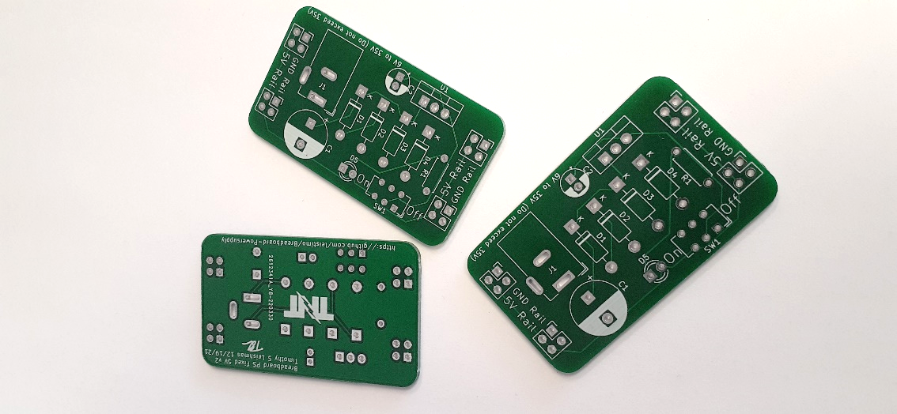While the power supply may not be the most exciting aspect of your electronic projects it is a crucial and foundational component. Poor power supply design can lead to intermittent circuit problems, premature circuit failures, and worst of all frustration. Understanding how power supplies function will make you a better electronic troubleshooter. The Breadboard Power Supply will give you the ability to safely build and test circuits. This small project will also help you develop your soldering skills and expose you to the circuit and PCB development process. Learning how to safely design and build dedicated power supplies will bring life to your current and future electronic projects.

Figure 3. Printed Circuit Boards (PCBs)

**A Problem named Covid**

In addition to the pandemic, Covid created an instant demand for online at home learning. Suddenly electronics students everywhere lost access to Laboratory Bench Test Equipment and the direct supervision of a Lab Instructor. Modestly priced oscilloscopes, function generators, and laboratory DC power supplies exist and I encourage advanced students to acquire these tools as they can. However, the introductory student will not likely have access to these type of tools at home and for them the Breadboard PS along with a DMM will provide a, affordable and safe, at home circuit prototyping opportunity.

**RMS & Peak Voltage**

The wall outlet at your house is 120-volt rms. 120vrms is dangerous. The protection circuit breaker which acts like a safety switch, turning off the voltage, has the maximum current rating of 15 amps to 20 amps. Death can occur from as low as 100mA or 0.1A. The circuit breaker at your house is not designed to save your life from electrical shock, it is designed to prevent the wiring in your home from overheating heating and starting a fire. Do not mess 120v wall power it can kill you!

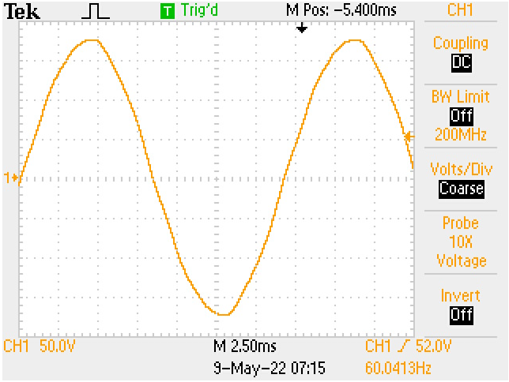Wall voltage known as AC (Alternating Current) voltage. Most of what we do in electronics is DC (Direct Current). Examples of DC devices include: your computer, cell phone, Arduino, Raspberry Pi, and all things powered by batteries. The motors in your RC car are DC. However, some motors are designed to operate using single phase AC or industrial three phase AC voltage. Because our wall power is AC and our electronic circuits are mostly DC we will need to convert the alternating wall current to direct current. The process of converting AC to DC is called Rectification.

Figure 4. 120vrms waveform on oscilloscope

Figure 4 shows a captured image of 120vRMS wall AC. Observe that the Oscilloscope displays the image in alternating peak to peak voltage not RMS voltage. To convert peak to peak voltage to RMS the following formula can be used; $Vrms= \frac{Vp}{\sqrt{2}} OR \frac{Vp}{0.707}$. $Vp$ is peak voltage and is equal to $Vpp ($ peak to peak voltage) divided by two ( $Vp=\frac{Vpp}{2}$). An Oscilloscope displays voltage along the Y axis and time along the X axis. In figure 5 note that channel 1 is set to 50 volts per division and have approximately six major divisions and two half divisions equaling 7 major divisions peak to peak. Now if we multiply $7div×50v/div$ we get a peak to peak voltage of $350vpp$. Dividing $350vpp$ by 2 gives us a peak voltage of $175vp$. Dividing $175vp$ by $\sqrt{2}$ gives an RMS voltage of $123.74vRMS≈120vRMS$. Peak voltage is important to understand when we are using an oscilloscope and calculating rectification circuits. RMS is used for determining AC power. For example, the power calculations for an incandescent light bulb, audio amplifier, and ac motor would be calculated by multiplying the RMS voltage by the RMS current.

**Voltage Rectification**

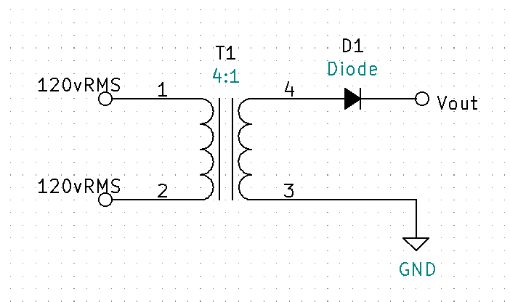Voltage rectification is the process of changing AC (alternating current) to DC (direct current). Knowing that 100mA’s of current can be lethal and that the general skin resistance of a human is between 10KΩ & 1KΩ (when wet), we can use Ohm’s Law, where $Current=\frac{Voltage}{Resistance}$, to determine a relatively safe voltage. If we convert 120vrms to peak we get $vp=120V×\sqrt{2}$ or $vp=169.71vp$. Now assuming we were able to rectify the 169.71volts we now use the human resistance of 1KΩ to determine the current potential, $i amps=\frac{169.71v}{1000Ω}$, $i=169.71mA$. This current is potentially lethal to a human. If 100mA is our 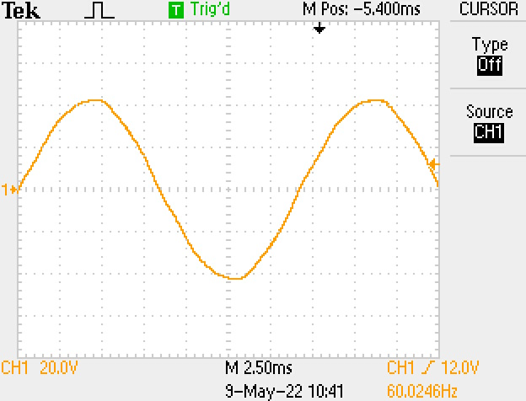threshold for lethal current we can calculate the max voltage by $V_{max}=1KΩ×100mA$, $V_{max}=100v$. Now we know that 100v and above are lethal voltages for humans and less than 100v should be less than lethal. Figure 5 shows a basic unregulated half-wave voltage rectifier, transformer T1 is used for isolation and safety. Notice that T1 has a 4:1 turns ratio. T1 is a step-down transformer meaning that the primary side (pins 1 & 2) have four times more turns than the secondary side (pins 3 & 4). A step-down transformers secondary voltage will be divided by the turns’ ratio. For this example, $v_{Secondary}=\frac{V_{primary}}{4}=\frac{169.71vp}{4}=42.43vp$. Figure 6 shows the secondary voltage waveform from T1 pin 3 to pin 4. The voltage has been stepped down to around 42vp. The waveform however, is still AC. Notice the frequency for both fig 4 and fig 6. Frequency is measured in hertz (Hz) you will see that both the primary and the secondary are measuring at 60Hz which is the standard frequency for AC power in the United States.

Figure 5. Basic unregulated half-wave rectification

Figure 6. transformer secondary voltage waveform

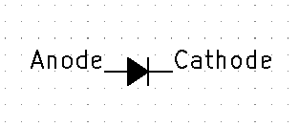The diode D1 will achieve rectification by acting like a switch and allowing current to flow in only one direction. When the anode is positive with respect to the cathode, current will flow. When the anode is negative with respect to the cathode the diode will act like an open switch and no current will flow. The output 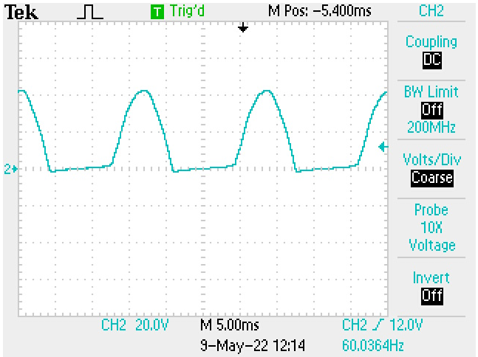waveform will now appear to have the negative peaks clipped off (See fig. 8). The current is flowing in one direction and basic half-wave rectification has been achieved. Notice the waveform frequency is still 60Hz for half-wave rectification.

Figure 7. diode anode and cathode

Figure 8. half-wave rectification

**Capacitive Filtering**

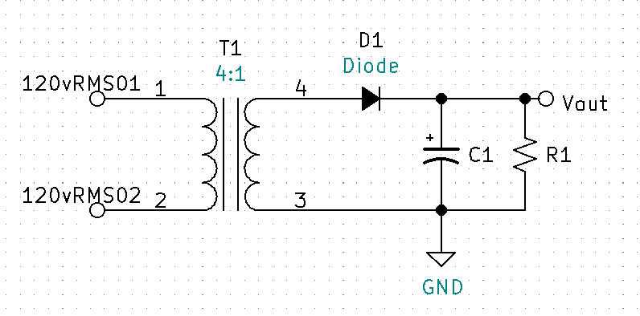By adding a filtering capacitor, we can smooth the ripple waveform to make it more like a smooth DC. Figure 9 has added a filter capacitor C1 and load resistor R1. The capacitor will charge immediately when the diode D1 is forward biased. When the diode becomes reverse biased the capacitor will discharge through the load R1. With a large enough capacitance value and load resistor the output will be a smooth DC. We can test this by using a 10uF capacitor with no load, a 10KΩ load, and a 1KΩ load to show the varying degrees of ripple (see figures 10, 11, & 12).

Figure 9. basic unregulated rectifier with filtering

**Calculating DC Voltage**

When there is ripple present on the waveform, VDC can be thought of as the average waveform voltage. VDC can be calculated by adding the maximum positive peak voltage to the minimum peak voltage and then dividing the sum by two.

Example Calculate $V_{DC}$ for figure 12:

$V_{DC}=\frac{V_{max}+V_{min}}{2}$

$V_{max}=2.1 div×{20v}/{div}=42v$

$V_{min}=0.5 div ×{20v}/{div}=10v$. Now find $V_{DC}$.

${VDC}_{1KΩ}=\frac{V_{max}+V_{min}}{2}= \frac{42v+10v}{2}=26V$.

**Un-Regulated**

Observe that as the load is increased (Ohm’s law $I=\frac{V}{R}$, current or “load” increases as resistance is decreased), the voltage ripple waveform increases and as the ripple increases the effective DC voltage is decreased. This is an example of a rectifier circuit that is Un-Regulated. An un-regulated power supply’s DC voltage will fall as the circuit load current is increased.

Figure 10. no load

Figure 11. 10K ohm load

Figure 12. 1K ohm load

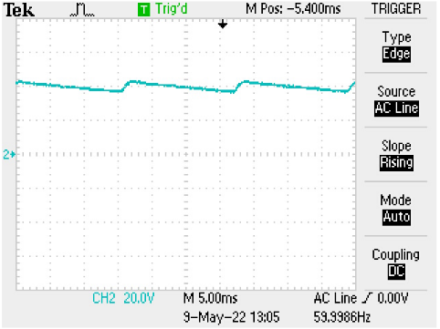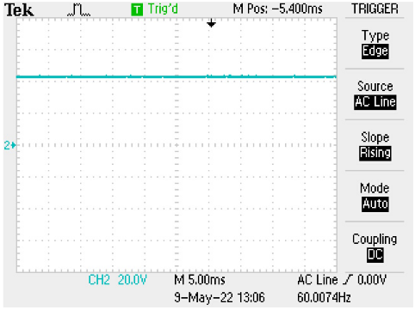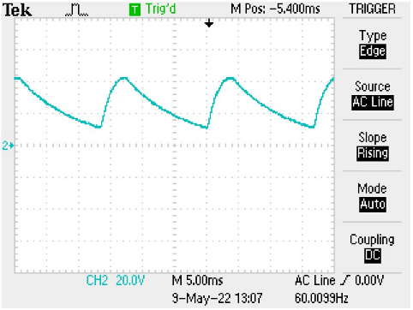

**Voltage Regulation**

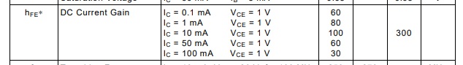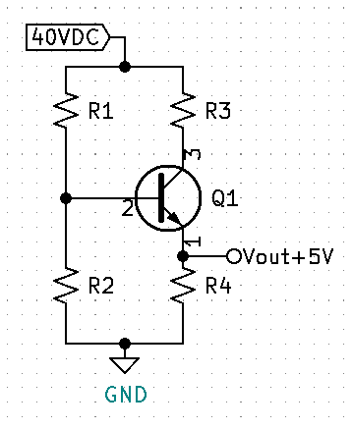 For many circuits having an unregulated power supply is a problem. Voltage regulation is required for any circuit that requires smooth consistent DC voltage across varying loads or current demands. Figure 13 shows a common collector amplifier which can be used to provide basic voltage regulation. To calculate the needed resistors R1 thru R4, an output voltage must be determined. Next, determine the maximum current need for your circuit. For this example, we will use 5V with a maximum current need of 5mA. Calculate the base current (pin 2) of the transistor by dividing the 5mA emitter current (pin 2) by the minimum beta (aka hfe) per the data sheet. For the 2n3904. The minimum hfe for the 2n3904 with a collector current near 5mA will be will be between 80 and 100, see figure 14.

Figure 13. beta for a 2n3904 transistor

Figure 14. basic voltage regulation circuit

$I_{B}≈\frac{5mA}{90}≈55.556μA$

With IB known, make IR2 a minimum of 10 times larger.

$I_{R2}≥(10×I_{B)}≥(10×55.556μA)≥555.556μA$

Use Kirchhoff’s Voltage Law to calculate VR2.



$V_{R2}=V_{R4}+V_{BE}=5V+0.7V=5.7V$

Use Ohm’s Law to calculate R2

$R_{2}=\frac{V_{R2}}{I_{R2}}=\frac{5.7V}{min555.556μA}=10.26KΩ$

* Round down to next standard value, $R_{2}=10KΩ$

Recalculate IR2 using standard value.

$I_{R2}=\frac{V_{R2}}{R_{2}}=\frac{5.7V}{10KΩ}=570μA$

Calculate IR1 using Kirchhoff’s Current Law.

$I_{R1}=I_{B}+I_{R2}=55.556μA+570μA=625.556μA$

Calculate VR1 using Kirchhoff’s Current Law.

$V_{R1}= V_{CC}-V_{R2}=40V-5.7V=34.3V$

Calculate R1 using Ohm’s Law.

$R_{1}=\frac{V_{R1}}{I_{R1}}=\frac{34.3V}{625.556μA}=54.831KΩ$

R3 is used to help split the power from the transistor. Power for the transistor is calculated using the max current multiplied by VCE.

* + Now make $V_{CE}= \frac{V_{CEmax}}{2}=\frac{35}{2}=17.5V$

$P_{Q1}=I_{Cmax}×V_{CE}=5mA×17.5V=87.5mW$

Calculate VR3 using Kirchhoff’s Voltage Law.

$V_{R3}=VCC-VCE-VR4=40V-17.5V-5V=17.5V$

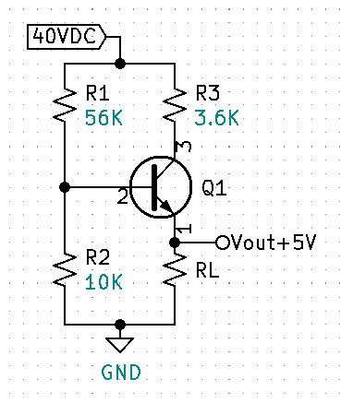Calculate IR3.

${IR}_{3}≈5mA$

Calculate R3 using Ohm’s Law.

$R_{3}=\frac{V_{R3}}{I_{R3}}=\frac{17.5V}{5mA}=3.5KΩ$

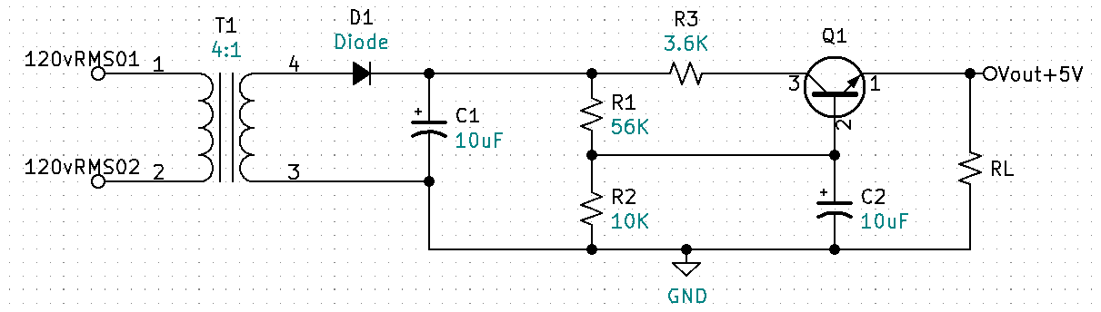Figure 15 displays the regulation circuit with standard values. Figure 16 shows the entire rectification circuit with the voltage regulation added. Notice the second 10uF capacitor C2 at the base of the transistor. This is used to keep the voltage and current at the base of the transistor extra stable. Figure 16 transistor orientation is also drawn in the more typical manner for a power supply.

Figure 15. basic rectification circuit with basic voltage regulation

Figure 16. basic regulation circuit with standard values.

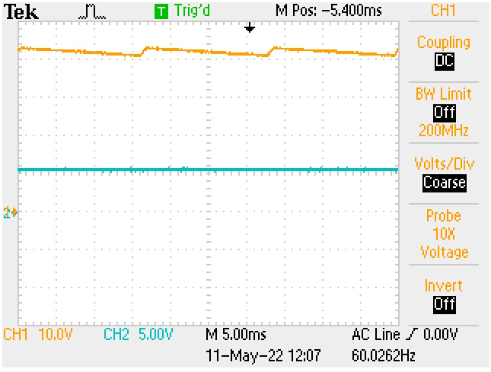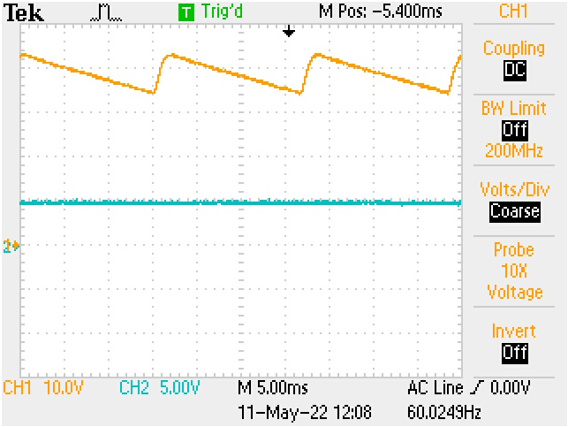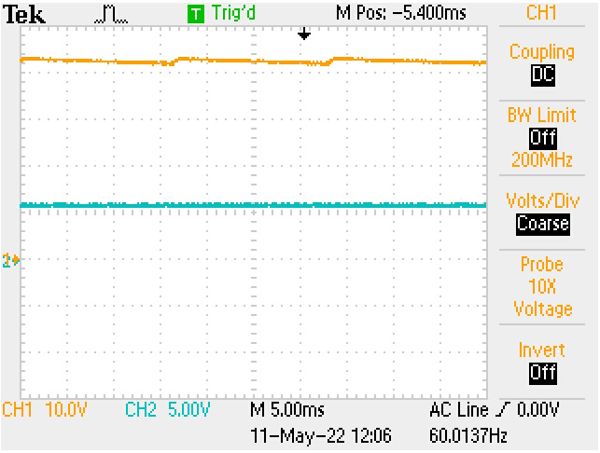**Voltage Regulation Measured Output Waveforms**

Figure 17. CH2 regulated Vout, 1K ohm load

Figure 188. CH2 regulated Vout, 10K ohm load

Figure 19. CH2 regulated Vout, no load

Observe Figure 17, 18, & 19. CH1 is the rectified input voltage across capacitor C1. CH2 is the regulated output which maintains a consistent DC voltage with no ripple from no load to a 1KΩ load. If you look closely you can see a very small and tolerable shift in the DC level (approximately 0.5V) from no load to 1k. Now let’s practice what we have learned by designing basic 5VDC regulator using a 9VDC battery.

**Your First Power Supply Project**

We learned previously that the human body skin resistance is around 1KΩ when wet and 10KΩ when dry. We also learned that a current of 100mA is potentially lethal. If we use a 9VDC battery as our voltage source, what is the maximum current through wet skin and minimum current through dry potential exposure (use Ohm’s Law)?

* Wet skin: ${ I}_{wet}=\frac{V}{R}=\frac{9V}{1KΩ}=9mA$
* Dry skin: $I_{dry}=\frac{V}{R}=\frac{9V}{10KΩ}=900μA$

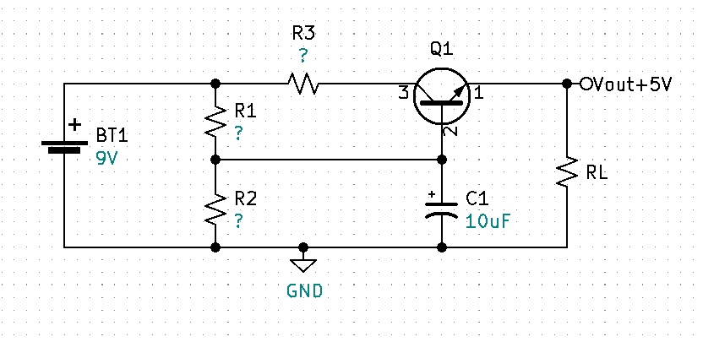With dry skin you will not be able to feel or perceive the less than 1mA of current from a 9V battery. If wet however, you could feel a non-lethal shock. Additionally, remove all metal jewelry prior to working with electronics.

Figure 20. 5V regulator using a 9V source

**First Challenge:** Calculate and find the resistor values for the circuit in Figure 20 to produce a regulated 5V output with a max current of 5mA, assume Q1 is a 2n3904 with a minimum beta of 90.

**Solution for First Challenge**

Find the maximum base current IB for Q1.

$I_{Bmax}≈\frac{I_{Emax}}{{Beta}_{min}}≈\frac{5mA}{90}≈55.556μA$

Make IR2 $≥$ 10 x IBmax.

$I_{R2}≥10×55.556μA≥555.556μA$

Find VR2 using Kirchhoff’s Voltage Law.

$V_{R2}=V_{BE}+V_{RL}=0.7V+5V=5.7V$

Find approximate R2 value using Ohm’s Law.

$R_{2}≤\frac{V_{R2}}{I_{R2}}≤\frac{5.7V}{555.556μA}≤10.26KΩ$

Round R2 value down to a standard value.

$R_{2}=10KΩ$

Recalculate IR2 using Ohm’s Law.

$I_{R2}=\frac{V_{R2}}{R_{2}}=\frac{5.7V}{10KΩ}=570μA$

Find IR1 using Kirchhoff’s Current Law.

$I_{R1}=I_{R2}+I_{B}=570μA+55.556μA=625.556μA$

Find VR1 using Kirchhoff’s Voltage Law.

$V_{R1}=V_{BT1}-V_{R2}=9V-5.7V=3.3V$

Calculate R1 using Ohm’s Law.

$R_{1}=\frac{V_{R1}}{I_{R1}}=\frac{3.3V}{625.556μA}=5.28KΩ$

Determine R3. First ask yourself what the total power of Q1 is without R3 and if that power needs to be split?

$P_{Q1}=I_{Cmax}×VCE$

$V_{CEmax}= V_{BT1}-V_{RL}=9V-5V=4V$

$I_{Cmax}=5mA$

$P_{Q1}=I_{Cmax}×VCE=5mA×4V=20mW$

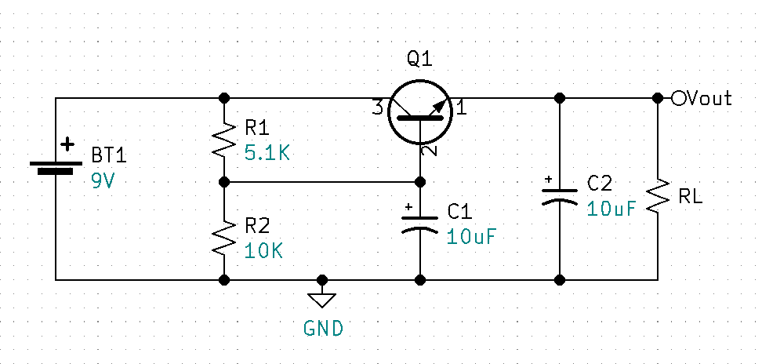The absolute maximum power rating for a 2N3904 is 625mW. Optimal power operation for the 2N3904 will be less than or equal to half the absolute maximum rating, approximately 300mW. Because we are well below the optimal power operation at 20mW, R3 is not required for this circuit.

Figure 21. Test Circuit - R1 Standard Value, Additional Filter Cap C2.

Figure 21. Assembled and the output measured 5.04V with a 1KΩ load resistor and 5.44V with no load. This circuit works good for a specific input voltage, in this case 9VDC. Let’s say we want to design a circuit that has the ability to accept a variety of input voltages instead of just 9V. How might we deal with a range of input voltages and still maintain a regulated output of 5V?

**Zener Regulation**

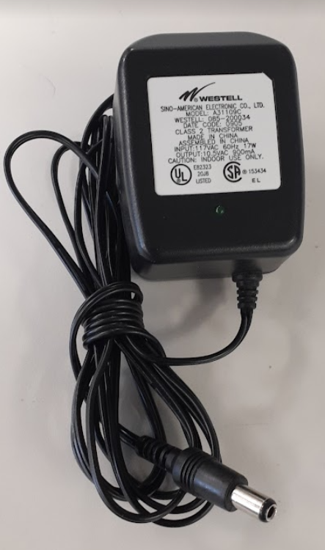 If you are like me, you have a box full of salvaged electronic components. I have one dedicated to wall AC to DC power adapters as seen in Fig. 22. These wall adapters, sometimes referred to as “wall warts” take care of voltage rectification for us by internally converting the 12Vrms AC voltage to a fixed DC voltage. Typically, the output voltage and current specifications are written on the adapter. The adapter in Fig 22. is listed as having an output of 10.5V that can supply up to 900mA. Let’s say I also have a wall adapter that has a 12V output and third that has a 20V output. Can we design a single circuit that will accommodate each of those inputs and still provide a regulated 5V output? By replacing R2 in our previous circuit with a Zener diode we can achieve regulation throughout a range on input voltages.

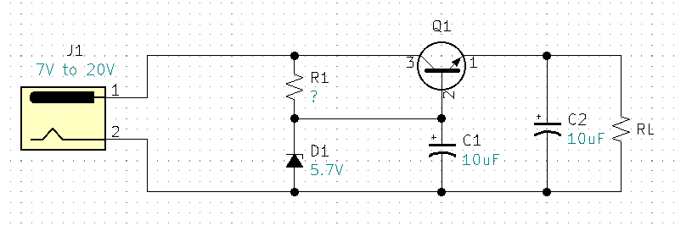

Figure 22. Zener regulation circuit with barrel jack input

Figure 23. AC to DC wall power adapter

with barrel jack connector

**R1 Calculations for Fig 23.**

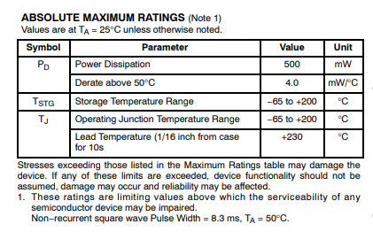Ideally D1 would be a 5.7V Zener, I had on hand a 1N5233 6V Zener diode. There are two important specifications we need to know, the maximum Zener current ($I_{ZM}$) and the minimum Zener current ($I_{ZK}$), known as knee current. According to the data sheet the maximum power for the Zener is 500mW. With this information we can calculate $I_{ZM}$.

Figure 24. Data Sheet Excerpt for 1N5233

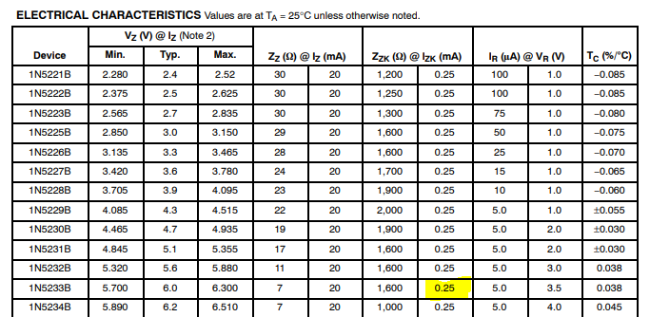 Calculate $I_{ZM}$ using the power formula.

Figure 25. Data Sheet IZK

$P=I×V$

$I=\frac{P}{V}$

$I_{ZM}=\frac{P_{ZMax}}{V_{Z}}=\frac{500mW}{6V}=83.333mA$

According to the data sheet $I_{ZK}=0.25mA$.

You can determine your minimum input voltage by adding a minimum of two volts to your regulated output voltage. This extra voltage is needed for the linear regulator to have at least two volts VCE across the transistor. The transistor will lose regulation if its VCE drops too low. For our example with a 5V output we would need a minimum of a 7V input. No imagine that the input is 7V and the 6V Zener is doing its job. Using Kirchhoff’s Voltage Law, we can see that VR1 will equal 1V. Here is the math.

With the input Voltage set to 7V:

$V_{R1}=V_{in}-V_{Z}=7V-6V=1V$

Now we know that the Zener needs a minimum current of $I_{ZK}$ therefore, we can now find R1.

* $R_{1}=\frac{V_{R1}}{I_{ZK}}=\frac{1V}{0.25mA}=4KΩ$, round down to next standard value of 3.9KΩ

With the maximum input voltage of 20V chosen, verify $I_{Z}$ does not exceed $I_{ZM}=83.333mA$.

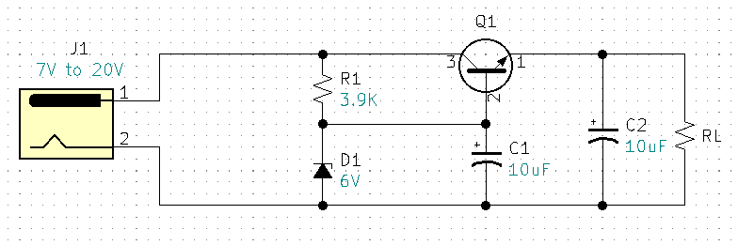With the input Voltage set to 20V:

Figure 26. Zener Regulated Circuit

$V_{R1}=V_{in}-V_{Z}=20V-6V=14V$

$I_{Z}=\frac{V_{R1}}{R_{1}}=\frac{14V}{3.9KΩ}=3.59mA$

* $I_{Z}$ is less that $I_{ZM}$, and within specifications.

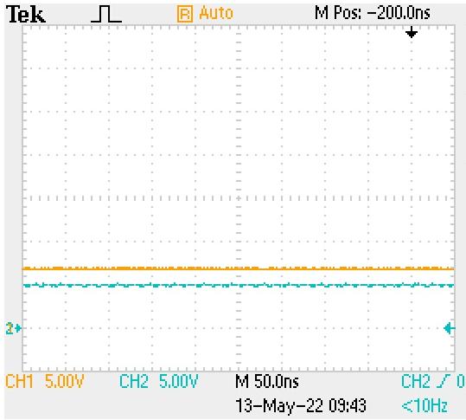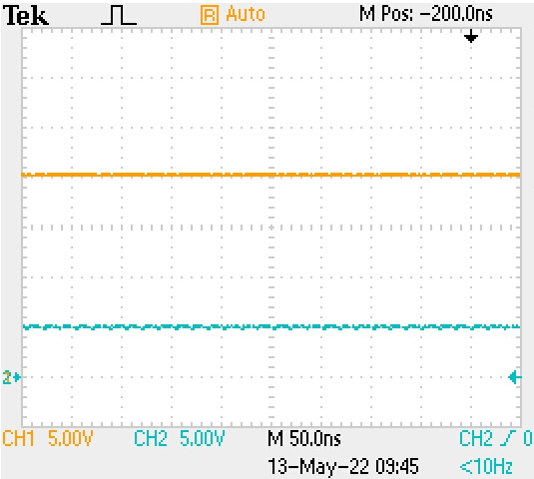One more calculation to check is the power Q1 when the input is at 20V.

Figure 27. Measured, Ch1 7V input & Ch2 5V output.

Figure 28. Measured, Ch1 20V input & Ch2 5V output.

$P_{Q1}=I_{RLmax}×V_{CE}$

$I_{RLmax}=5mA$

$V_{CEmax}=V_{INmax}-V_{RL}=20V-5V=15V$

$P_{Q1}=I_{RLmax}×V_{CE}=5mA×15V=75mW$

$P_{Q1}=75mW is less the maximum power for a 2N3904, P_{Max2N3904}=625mW$

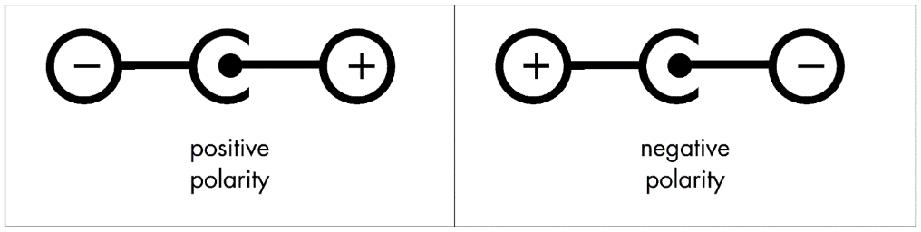With Zener regulation we can now regulate a range of input voltages. But only barrel jack connectors that have a positive center pin. Have you ever noticed the symbol markings on your AC wall adapters similar to Fig. 29? In my box of salvaged adapters, I have some unmarked, some center positive, and some center negative. Currently, we could damage our circuit or the adapter if we used unmarked or center negative adapters. How could our circuit be fix so that it could accept both positive and negative center polarities and still output a fixed +5V?

Figure 29. Barrel Jack polarity markings

**Input Polarity Correction**

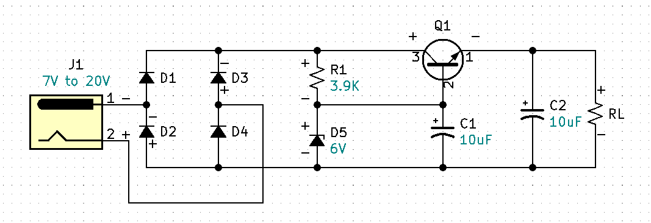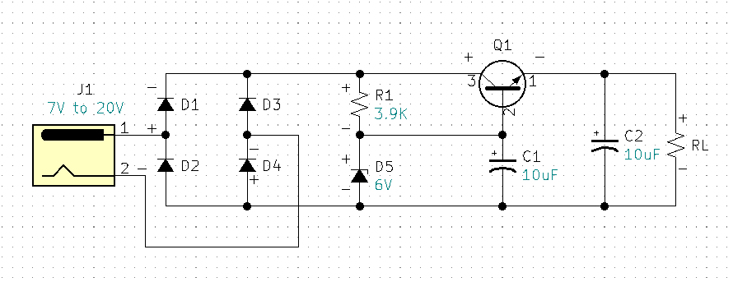 Similar to how we used diodes in our AC to DC voltage rectification circuit, we can use diodes to provide DC polarity correction. For this example, I am using 1N4001 general purpose diodes for D1-D4.

Figure 30. Input Polarity Correction, J1 Pin1 Negative.

Figure 31. Input Polarity Correction, J1 Pin1 Positive.

Observe Figure 30. When J1 pin 1 is positive with respect to pin 2, diodes D1 and D4 are forward biased and diodes D2 and D3 are reverse biased and acting like open switches. The result is the rest of the circuit is properly biased. Observe Figure 31. When J1 pin 1 is negative with respect to pin 2, Diodes D2 and D3 are forward biased and diodes D1 and D4 are reverse biased and acting like open switches. The result is the rest of the circuit is again properly biased. Therefore, the circuit is now adapted to receive either positive, negative, or unknown voltage polarities. This circuit makes virtually all of our salvaged wall adapters useable. Assembled and tested circuit with +20VDC input measured +5.08VDC at the output with a 1KΩ load. Also tested with -20VDC input and measured +5.08VDC at the output with a 1KΩ load. What happens to this circuit if the output is shorted? The answer is the transistor will exceed its power specifications and destroy itself. None of the previous circuits have current limiting protection. If you are building a dedicated circuit that will be deployed with a fixed load and a fixed input voltage, the previous circuits may work fine. If you are doing a lot of prototyping or if you have novice users working with your circuits you may want current limiting protection. What might be a simple way to apply current limiting protection to this circuit?

**Basic Current Limiting Protection**

Figure 32. Simple current limiting protection provided by F1 fuse.

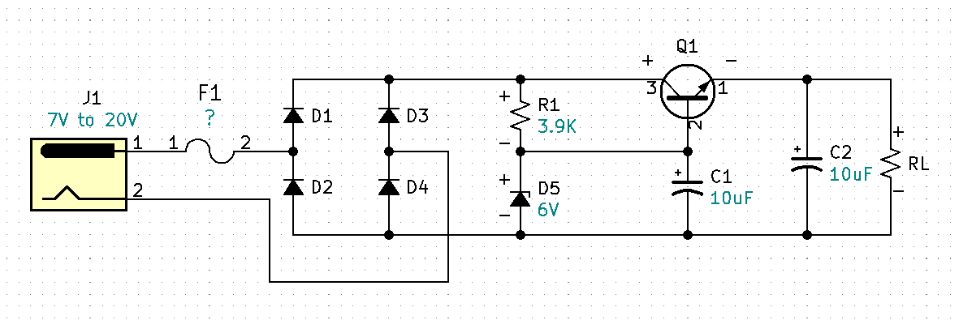The answer is a fuse.

To determine the proper fuse value, we need to consider all the parts that will be affected when the output is shorted or overloaded. We can see that Q1 and the polarity correction diodes are in the direct path between the voltage source and the output. Additionally, we should consider the output rating on the AC/DC wall adapter. All wall adapter will be rated differently. As previously mentioned, my adapter is rated at 900mA. According to the data sheet the 1N4001 diodes are rated at a maximum forward current of 1A. And the 2N3904 BJT is rated at an absolute maximum forward DC current of 200mA. So, for this circuit we will need to protect the weakest link which is the 2N3904 BJT at 200mA. If your wall adapter is rated less than 200mA, your fuse choice would be based on that current. Because 200mA is the absolute maximum, we will want to guarantee that the current stays well below 200mA. Our circuit is designed to run at 5mA so our fuse will need to be larger than 5mA and well below 200mA. An appropriate fuse for this circuit is a slow blow 100mA or 0.1A fuse.

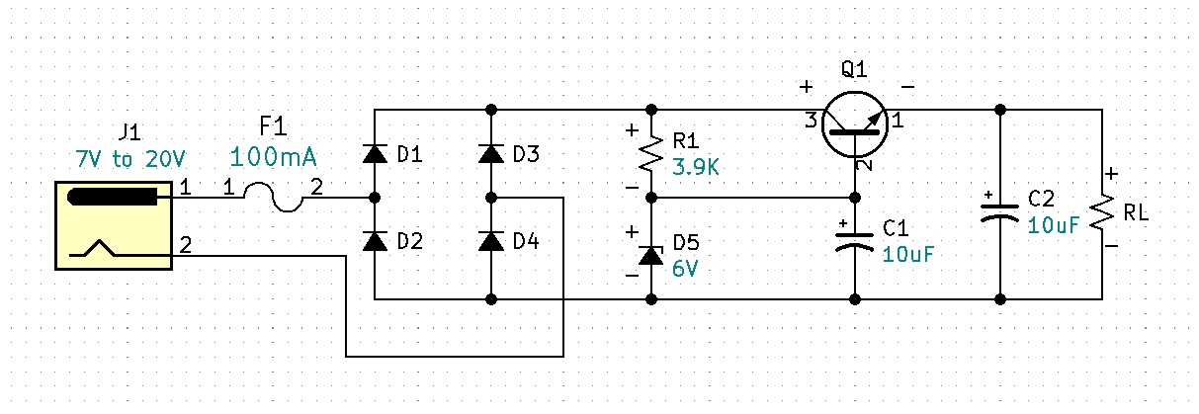

Figure 33. Fuse F1 = 100mA or 0.1A

**Re-analyze circuit at 100mA**

We need to now analyze at a circuit current of 100mA to determine if PQ1 is still ok.

Calculate the load resistance.

$R_{L@100mA}=\frac{V_{RL}}{I_{RL}}=\frac{5V}{100mA}=50Ω$

$P_{Q1@100mA}=V_{CEmax}×I_{Cmax}$

$V_{CEmax}=V_{INmax}-V_{RL}=20V-5V=15V$

$I_{Cmax}=F1=100mA$

$P_{Q1@100mA}=V_{CEmax}×I_{Cmax}=15V×100mA=1.5 watts$

$P_{Q1}$ at 1.5 watts is too high for the 2N3904. There are two ways we could deal with this problem. The first is to do a power split by adding a series parasitic power resistor in the path of the collector of the transistor just like we did previously with R3 in the rectifying circuit Fig. 15. The second is the Darlington Pair.

First let’s calculate the parasitic power resistor.

$P_{total}=1.5 watts$

$P_{Q1max}=625mW$

$P_{R2max}=P_{total}-P_{Q1max}=1.5 watts-625mW=875mW$

$V_{R2}=\frac{P_{R2max}}{I_{Cmax}}=\frac{875mW}{100mA}=8.75V$

$R_{2}=\frac{V_{R2}}{I_{Cmac}}=\frac{8.75V}{100mA}=87.5Ω$

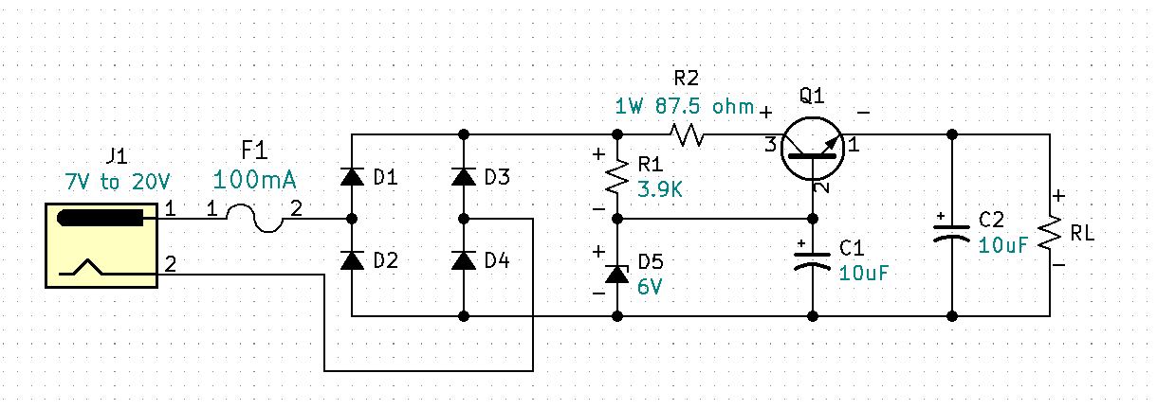 This circuit will work fine when the load is 5mA. However, now that we can operate up to 100mA without damaging any of the parts, a new problem has been introduced via R2. Can you spot the problem? If want to operate our output at 99mA, what is the required input voltage for Fig 34.?

Figure 34. Parasitic R2 power protection for Q1

Calculate the input voltage when the output is running a 99mA load.

$V_{in}=V_{D1}+V_{D4}+V_{R2}+V_{CE}+V_{RL}$

$V_{D1\&D4}=0.7V$

$V_{R2}=I_{C}×R_{2}=99mA×87.5=8.663V$

$V_{CE}=2V$

$V_{RL}=5V$

$V_{in}=0.7+0.7+8.663+2V+5V=17.063V$

$V_{in}=17.063V$

A Vin requirement of 17V for our circuit is not practical. Using this method severely limits the flexibility of this circuit. A preferable method is to use a Darlington Pair with a higher-powered transistor.

**Darlington Pair**

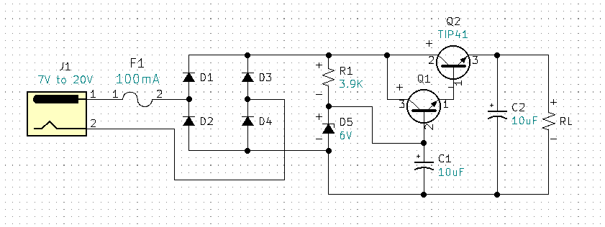The Darlington Pair is a current multiplier. The TIP 41 is able to handle more power and will significantly lower the current seen by Q1. Here is a question you may be thinking, why not just get rid of Q1 and replace it with the power transistor TIP41? And that is a great question and observation. The answer is power transistors have a much lower beta or hfe than general purpose transistors. Therefore, our base current would go up significantly and we would still need 10X current through the Zener and even if we were able to keep our current under IZM and if that worked we would have to recalculate our R1 value to provide more current. We don’t want to send more current to ground through the Zener because the negatively impacts our efficiency. By adding the Darlington we know that the Q1s base current will be significantly decreased which is ok because that means that the current through the Zener diode will be more (or much more) than 10X IB and R1 can be left alone.

Figure 35. Darlington Pair Q1 & Q2

**L7805 Regulator**

The L7805 is a 5V fixed linear regulator with internally limited current and temperature protection. The L7805 can accept input voltages from 6V to 35V. The L7805 is part of a L78 series of linear regulators. The L78 series can be purchased as 5V, 6V, 8V, 8.5V, 9V, 12V, 15V, 18V, and 24V regulators. One point to understand is linear regulators can only regulate down, the cannot regulate up meaning the minimum input voltage for a 12V regulator must be 13V or more. For the L7805 5V regulator the input voltage can be 6V to an absolute maximum of 35V.

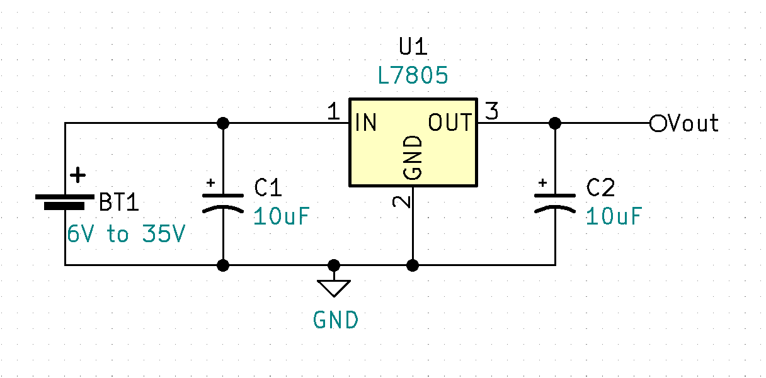

<https://www.osha.gov/sites/default/files/2019-04/Basic_Electricity_Materials.pdf>

<https://media.digikey.com/pdf/Data%20Sheets/ST%20Microelectronics%20PDFS/2N3904.pdf>

<https://www.onsemi.com/pdf/datasheet/1n5221b-d.pdf>

<https://i.stack.imgur.com/zsp7C.png>

<https://www.st.com/content/ccc/resource/technical/document/datasheet/41/4f/b3/b0/12/d4/47/88/CD00000444.pdf/files/CD00000444.pdf/jcr:content/translations/en.CD00000444.pdf>

<https://www.onsemi.com/pdf/datasheet/1n4001-d.pdf>

<https://media.digikey.com/pdf/Data%20Sheets/ON%20Semiconductor%20PDFs/TIP41A-D.pdf>